Design

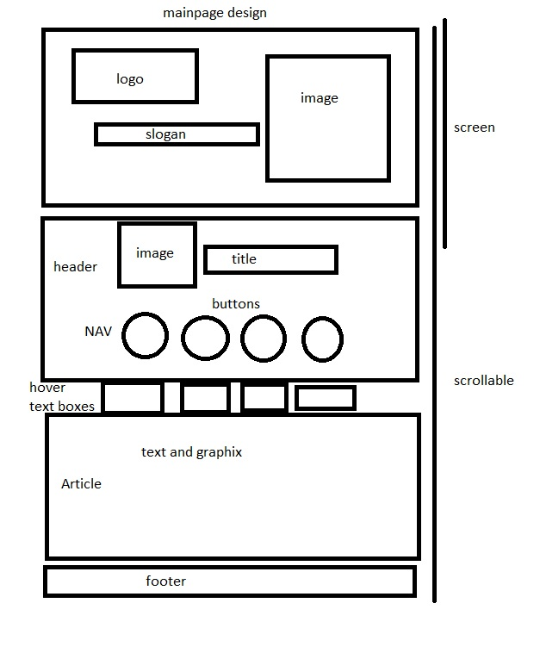

Photoshopping the image for on the main page.

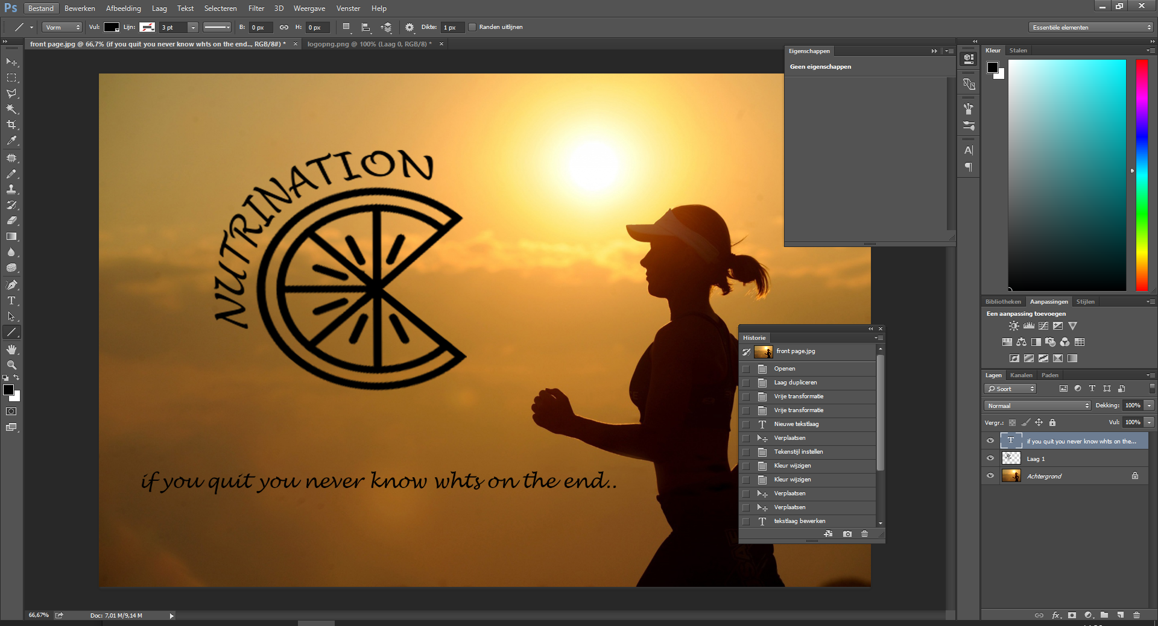

Constructing top of the page

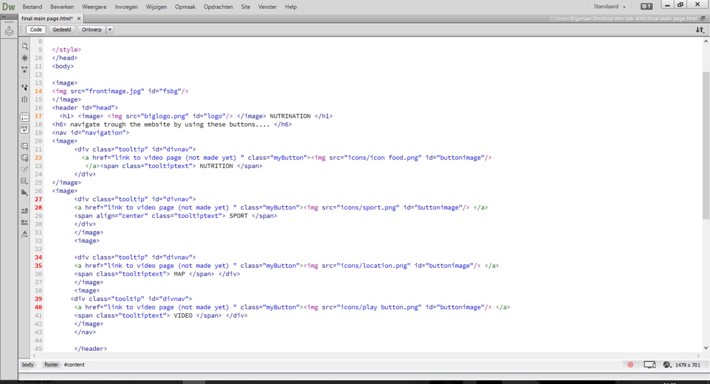

Constructing bottom of the page

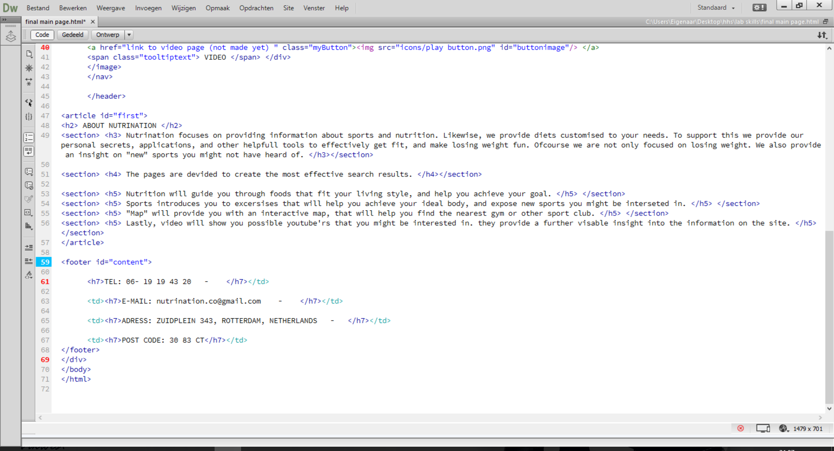

Fitting CSS THROUGHOUT PROGRESS

Look at file

Sprint 2

Maps page:

Used same code for header.

Implemented an iframe for the map

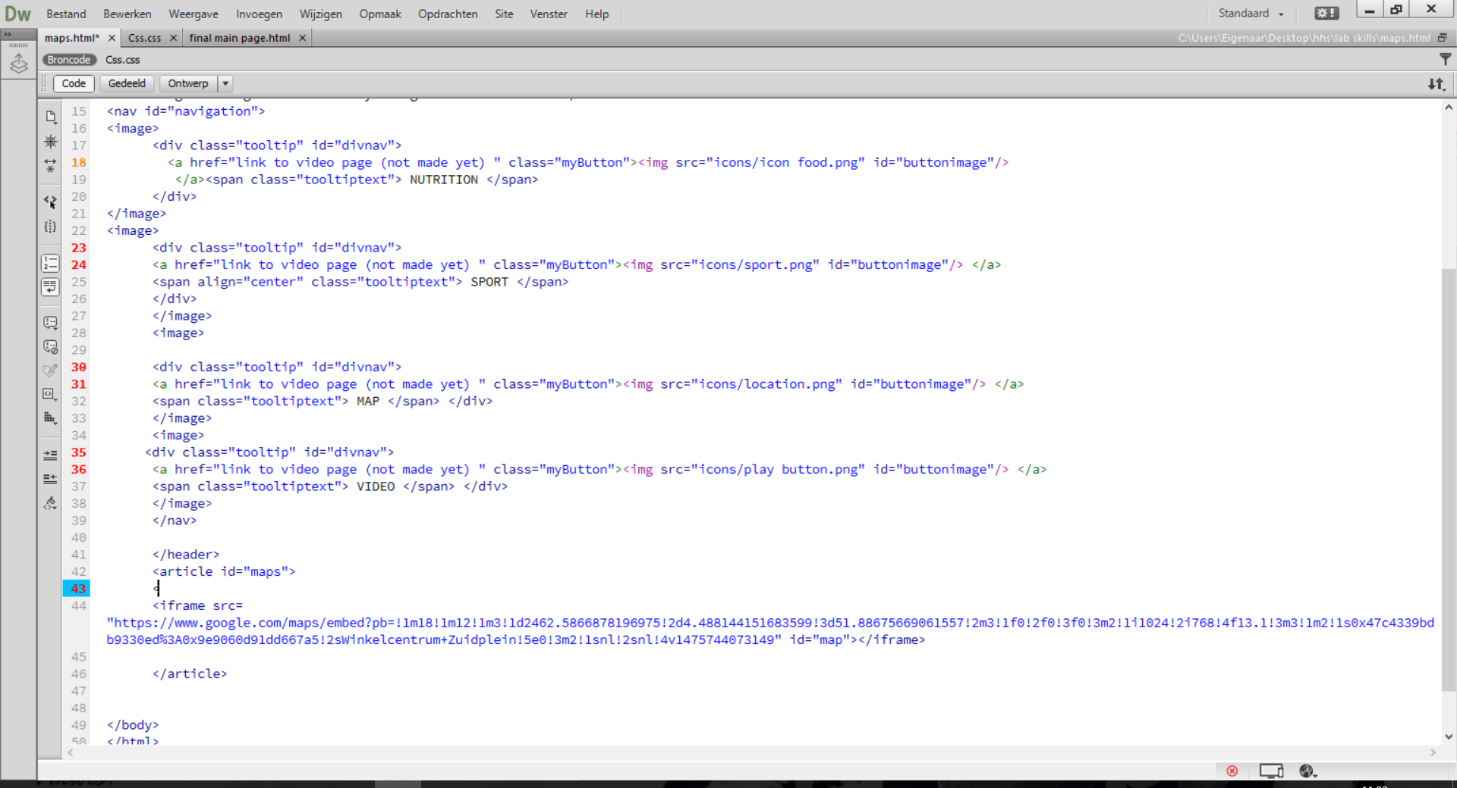

<https://www.google.nl/maps/place/Winkelcentrum+Zuidplein/@51.8867567,4.4881442,17z/data=!3m2!4b1!5s0x47c4339bdc95f223:0xefffd40d89d9d0b5!4m5!3m4!1s0x47c4339bdb9330ed:0x9e9060d91dd667a5!8m2!3d51.8867534!4d4.4903382>

implemented same footer

